|  |  |  |  |  |  |
| --- | --- | --- | --- | --- | --- |
| Group Project Meeting | | | | | |
| Minutes | | **15/02/2011** | **15h30🡪16h30** | | **room 4 (Library)** |
| Participants : Present – P / Absent – A / Absent without notification - X | | | | | |
| P | | Yannick Montesi (Project Leader, Minute Taker, Chairperson) | | |
| P | | Jasmin Terrien | | |
| P | | Edwin Chicouard | | |
| P | | Rodolf Rick | | |
| P | | Tasin Zarkoob | | |

Previous Meeting :

None.

## Discussion Items :

|  |  |  |
| --- | --- | --- |
|  | Action Items | Decision(s) |
| 1. | Android application design | Tasin has almost finished the design. We have decided to add a new activity page (list of places), and a login page /pop-up when the user will want to synchronize his trips/journeys.  (Page 2) |
| 2. | UML / Analysis | Edwin and Yannick have made the analysis of the website. The UML diagrams have to be completed. |
| 3. | SQL Lite / Android application | Rodolf and Jasmin confirm the use of SQL Lite, and its use between Android, Symfony and Doctrine. |
| 4. | Team communication | Yannick created the SVN, but it seems difficult to use and maintain it. Yannick will search if we can change to DropBox, or another system. |
| 5. | Project planning | We have divided the website and the application in tasks, and give an approximate time to complete each of them in order to begin the creation of the Gantt chart. (Page 2) |
| 6. | Corporate Design | Edwin has stated that we have to create a corporate design for the website. |

To do for the next week :

|  |  |  |
| --- | --- | --- |
| Actions to do | Description | Person(s) in charge |
| Create Database | Due to the website analysis, the databse can now be build. | Edwin |
| Website initialisation | The different softwares and frameworks must be configured, and a website « skeleton » or template must be created. | Rodolf |
| Android Internal Database | An internal database must be created and some classes must be created in order to interact with the internal database of the smartphone (save, load). | Jasmin |
| Design Application and Website | Some application design must be finished, and screenshots must be provided. After, the website design will be processed. | Tasin |
| Documentation | Project plan / Gantt Chart and corporate design must be created. | Yannick |
| Project Name | Think about a name for the project | All members |

Next meeting :

Tuesday, February 22th 2011

Android application Design :

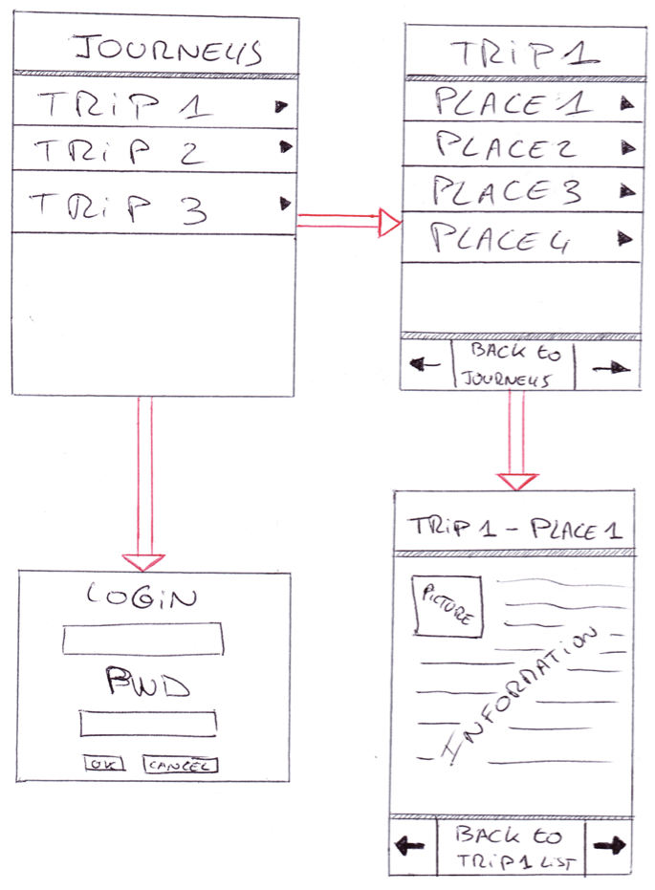

Project Planning (Draft) :

|  |  |  |  |  |  |
| --- | --- | --- | --- | --- | --- |
| Main Parts | Sub-Parts | Time (Normal) | Extra Time | Start Date | End Date |
| Website |  |  |  |  |  |
| **PRIORITY 🡪** | **Database** | **1 week** | **1 week** | **16th February** | **4th March** |
|  | Design | 2 weeks |  | 16th February | 1st March |
|  | Initialisation (PHP/framework) | 1 week |  | 16th February | 22th February |
|  | Implementation | 4 weeks | 1 week | 22th February | 29th March |
| Application |  |  |  |  |  |
|  | Design | 2 week |  | 8th February | 22th February |
|  | Interaction DB | 2 weeks | 1 week | 22th February | 15th March |
|  | Internal DB | 2 week |  | 16th February | 1st March |